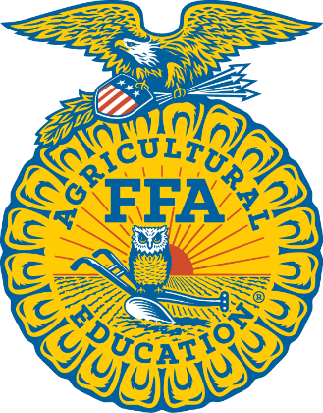

**Waco Midway FFA  
Alumni & Supporters Association**

**“FFA BOOSTERS”**

FFA Parent Info

***You do NOT need to be a former member of FFA.

This group is for parents, businesses and former FFA members***

Our goal is to help support, raise funds, and enhance our kids’ experience with Midway FFA.

All memberships benefit the Waco Midway FFA Alumni Association, see additional benefits with each level below.

American $250 Benefits: *voting rights*, 1 FFA decal, 1 Livestock Show T-Shirt, 1 FFA baseball cap, and recognition as American level member at the Midway FFA Banquet.

Lonestar $100 Benefits: *voting rights*, 1 FFA decal, 1 Livestock Show T-Shirt, and recognition as Lonestar level member at the Midway FFA Banquet.

Chapter $50 Benefits: *voting rights,*1FFA decal, and recognition as Chapter level member at the Midway FFA Banquet.

Greenhand $25 Benefits: *voting rights* & recognition as Greenhand level member at the Midway FFA Banquet.

Discovery FREE *no voting rights.*

Name(s): ______________________________________________________________________________

(Exactly as you want it to appear for recognition)

Address: ________________________________ City: ____________________ Zip Code: ___________

Phone #: _____________________________ Email: ___________________________________

Additional Phone #: _____________________ Additional Email: ___________________________________

(If more than one name included)

Student’s Name: _______________________________________________ Cash: ________ Check #_________

Student(s) Activities/Involvement: 🅪CDE 🅪LDE 🅪SAE 🅪SDE

🅪 Ag Classes: List Teacher and class period (can list more than one): ________________________________

_______________________________________________________________________________________

T-Shirt Size (for Lonestar & American Memberships ONLY): _________________

***Cannot guarantee incentives after November 30, 2024***

*Please make check payable to* Waco Midway FFA Alumni Association Membership. Each level will cover your membership with our local Alumni Association with the rest benefiting our program. In order for a Senior to be eligible for a scholarship, parent must be an active paid member for at least two years.

**FFA Lifetime National Alumni Association Memberships are $200.**

**Yes! I’d like to be a national lifetime member!**

This amount is in addition to the chapter membership fee that you choose.

Please add this amount to your check if you would like to be a national lifetime member.

**Please send form and payment with your child to school/ag teacher - attention:**

**Midway FFA Alumni Association**